|  |  |
| --- | --- |
|  | **CS314** |
|  | K112123 Section A k112018 Section C  May 16th, 2014 |

|  |
| --- |
| **[The Man Who was There]** |
| Validating Check-ins in Location-Based Services  **PROJECT REPORT** |

Table of Contents

**Project Description 3**

**Project Layout 3**

**Project Architecture 4**

*User Side 4*

*Places Side 4*

**Screen Shots 5**

**Platforms/Framework Description 7**

*User 7*

*Places 7*

*Middle Man 7*

**Further Enhancements 8**

Project Overview

# Project Description

*"The growing popularity of location-based services (LBS) has led to the emergence of an economy where users announce their location to their peers, indirectly advertising certain businesses. Venues attract customers through offers and discounts for users of such services. Unfortunately, this economy can become a target of attackers with the intent of disrupting the system for fun and, possibly, profit."*

# Project Layout

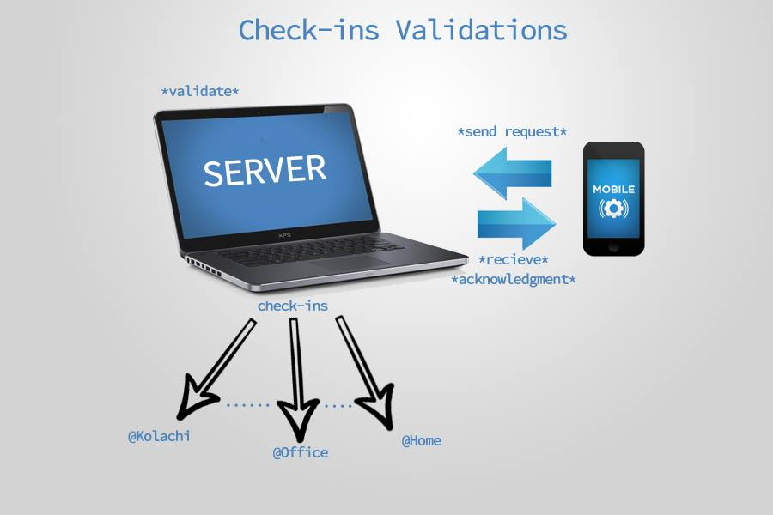

Proposed Solution

# Project Architecture

## User Side

* Users Have An interface where they can select place and login
* The GPS information of the user is sent along the check In request to the Main Server we call "Middle Man"
* The Middle Man contains a database with checkIn history of the users
* The Middle Man Applies Validation and GPS checks on the information received
* If it is valid, the Middle man sends an ACK to the sender and updates its own database
* The user is also shown top 3 people in contention for the mayor-ship of the place

## Places Side

* The Place query the Middle Man for latest result-set after short intervals, eg 2 sec
* The Middle Man Takes the place id and populates top three people on the leader board
* The top 3 member details and their check in count is returned back to the place

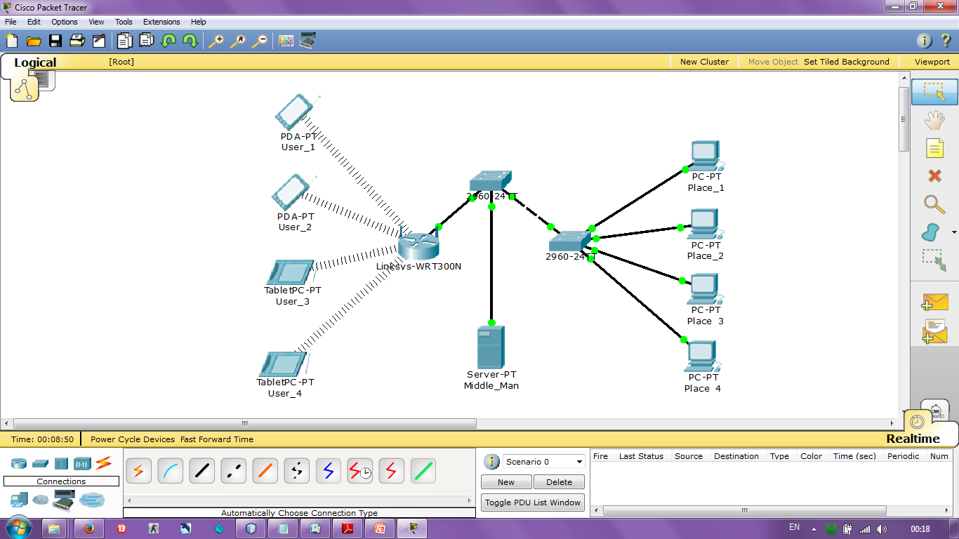

# Screen Shots

Places Screen

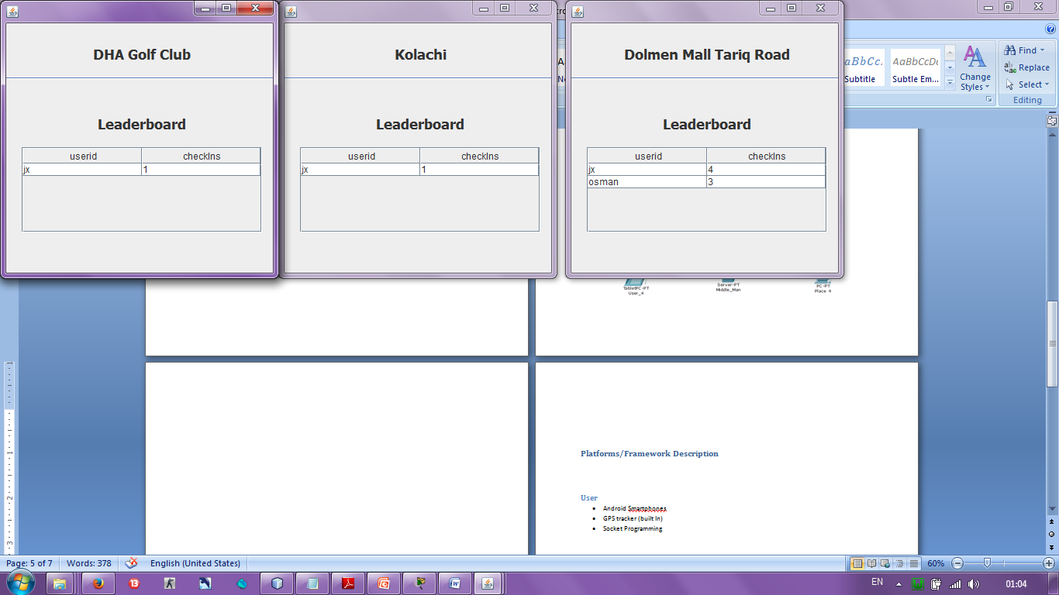

User View

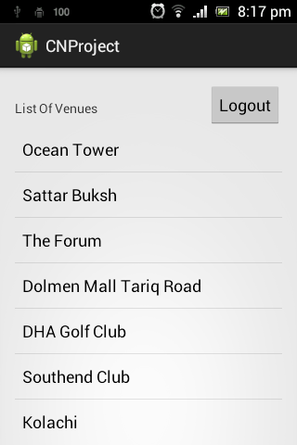

Middle Man LOG View

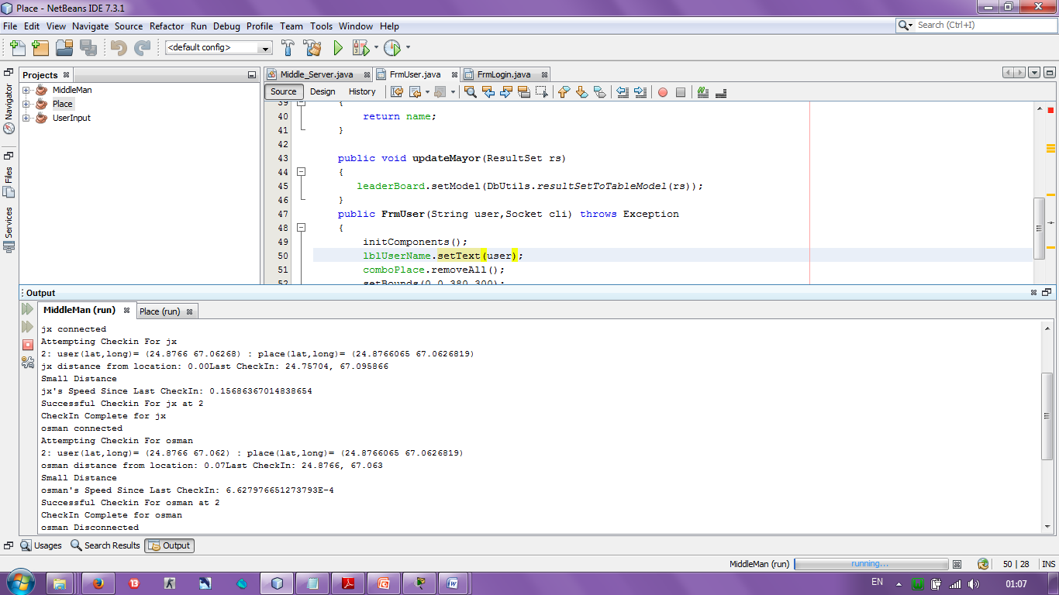

# Platforms/Framework Description

## User

* Android Smartphones
* GPS tracker (built In)
* Socket Programming

## Places

* Java Jdk1.7
* Socket Programming
* Dynamic Threading

## Middle Man

* JAVA jdk1.7
* Socket Programming on port number 10001
* MySQL database
* WAMP server
* Dynamic Threading on Socket Programming

Future Improvements

# Further Enhancements

* Use of NFC server to validate Check-Ins.
* Use of QR codes available at place itself to scan and send to middle man.
* middle man will also need to store a timeout variable.
* which can be implemented directly by using the "timeout" property of the socket.